
LSR505ML 1~50mW
Green Laser
FEATURES
TEC cooled
Longlife operation
Analog/TTL modulation
Collimated straight beam
High efficiency
High reliability

APPLICATIONS
Laser Alignment
Scanning Biochemistry

Specifications
Model No. | LSR505ML
Wavelength | 505+/-5 nm
Spatial Mode | TEM00
Output Power | 1, 10, …, 50mW
Operation Mode | CW or Modulation
Beam Size | 4.5mm
Beam Divergence(full angle) | 0.2mrad
Power Stability | <3% per 4 hrs
Temperature Stabilizing | TEC
Warm Up Time | <1 minute
MTTF | 10,000 hrs
Laser head dimensions | LSR-NL: 100(L)x40(W)x50(H)mm3
Power Supply | A. OEM type  LSR-PS-I: 100(L)x58(W)x32(H)mm3  AC/DC PSU: 85~265V 50/60Hz input
Power Supply | B. Lab type  LSR-PS-IIS: 104(W)x128(D)x89(H)mm3  85~265V 50/60Hz input
Power Supply | C. Lab Adjustable type  LSR-PS-IIS: 179(W)x148(D)x56(H)mm3  85~265V 50/60Hz input
Modulation | 0~30khz Analog or TTL

A. OEM type power supply LSR-PS-I+5V PSU
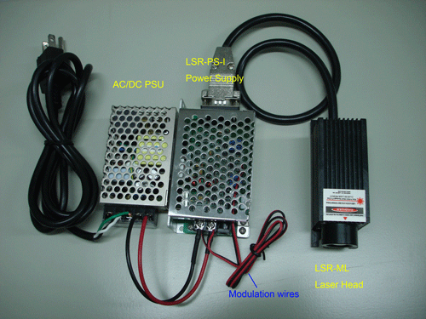

B. Lab type power supply LSR-PS-IIS
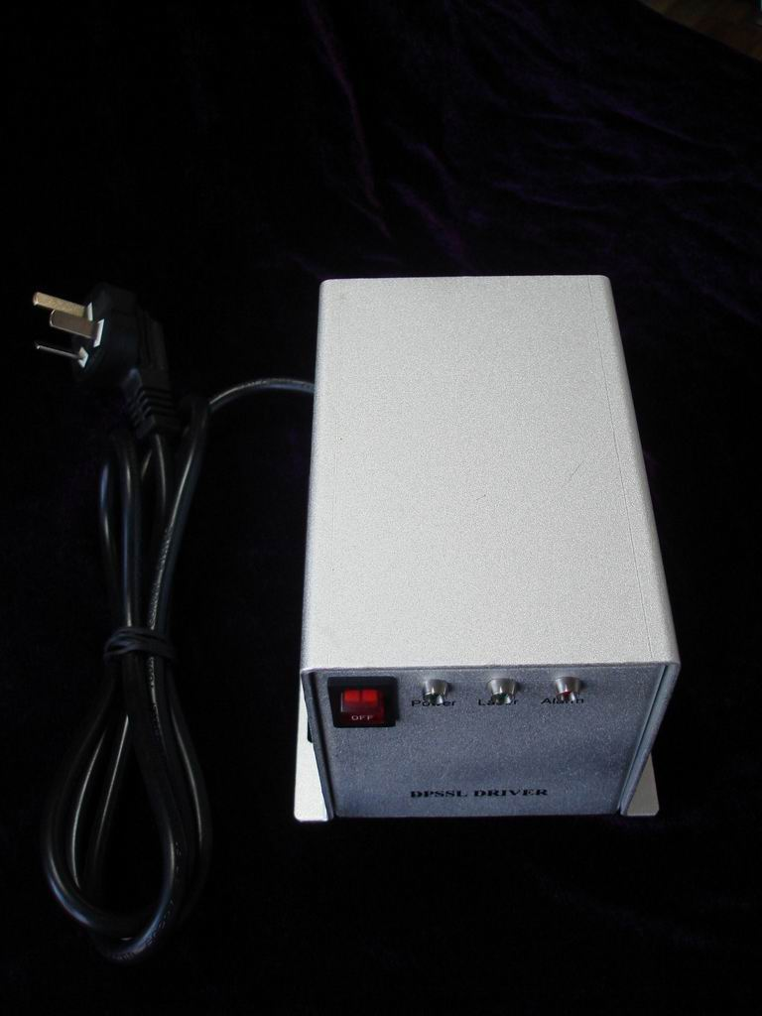

C. Lab Adjustable power supply LSR-PS-II
